**DAILY ONLINE ACTIVITIES SUMMARY**

|  |  |  |  |  |  |  |  |  |
| --- | --- | --- | --- | --- | --- | --- | --- | --- |
| **Date:** | **28-05-2020** | | | | | **Name:** | **Kanaka BS** | |
| **Sem & Sec** | **6th - A** | | | | | **USN:** | **4AL17CS039** | |
| **Online Test Summary** | | | | | | | | |
| **Subject** | | **OS-II** | | | | | | |
| **Max. Marks** | | **30** | | **Score** | | | **22** | |
| **Certification Course Summary** | | | | | | | | |
| **Course** | **Complete Python Developer in 2020** | | | | | | | |
| **Certificate Provider** | | | **Udemy** | | **Duration** | | | **30 hours** |
| **Coding Challenges** | | | | | | | | |
| **Problem Statemen:1.**Python program to find digital root of a number  **2.** JAVA PROGRM-BALANCED BRAKET 3. Given an array arr[] of size N and an integer K. The task is to find the last remaining element in the array after reducing the array 4. jsp code to display today’s date and time using expression tag 5. jsp script to determine how many times the visitor has loaded the page | | | | | | | | |
| **Status: executed** | | | | | | | | |
| **Uploaded the report in Github** | | | | | **yes** | | | |
| **If yes Repository name** | | | | | <https://github.com/kanakabs/Daily-Status/tree/master/28-05-20/online%20coding> | | | |
| **Uploaded the report in slack** | | | | | **Yes** | | | |

Online Test Details:

SECOND I A of OS

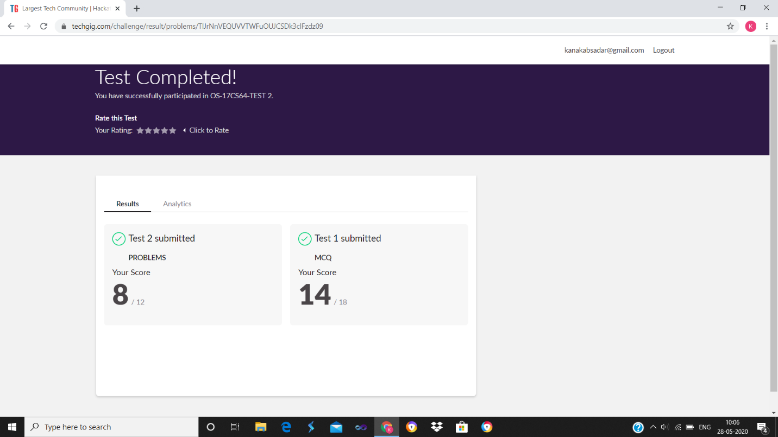

Certification Course Details

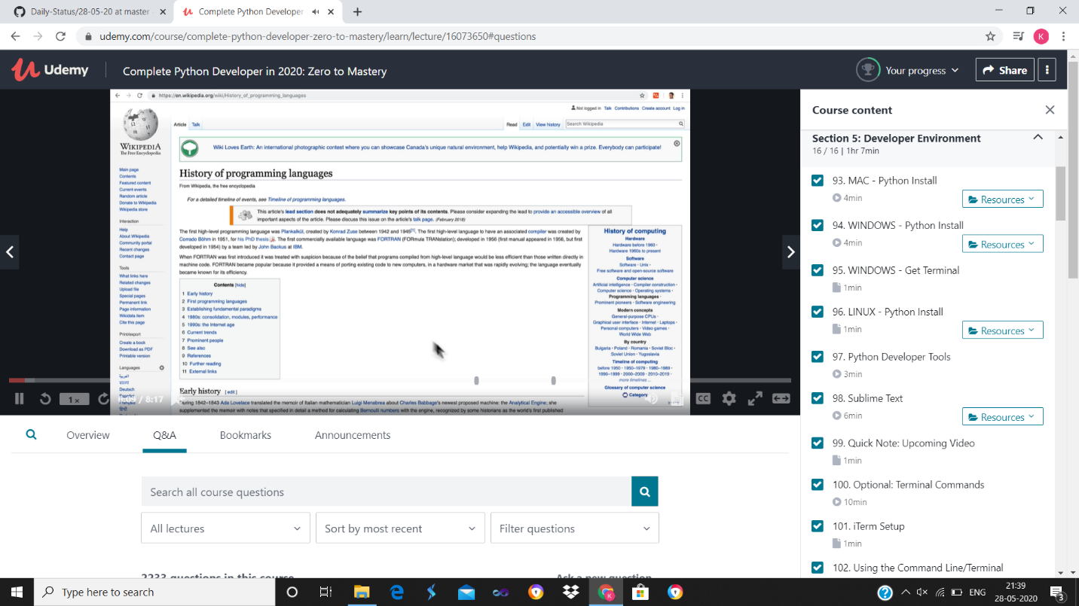

Coding Challenges Details:

P-1

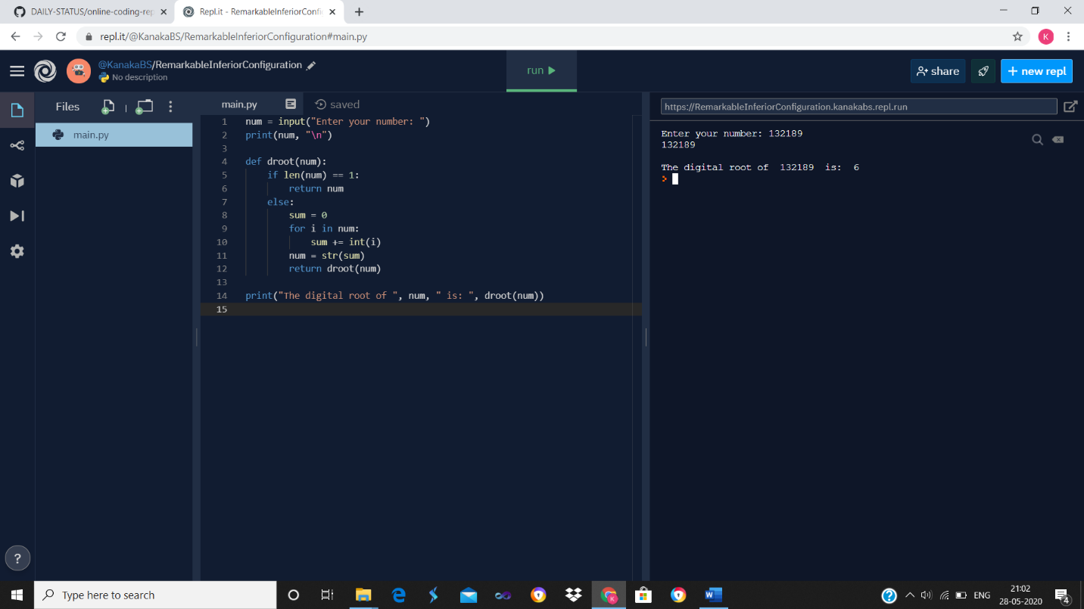

P-2

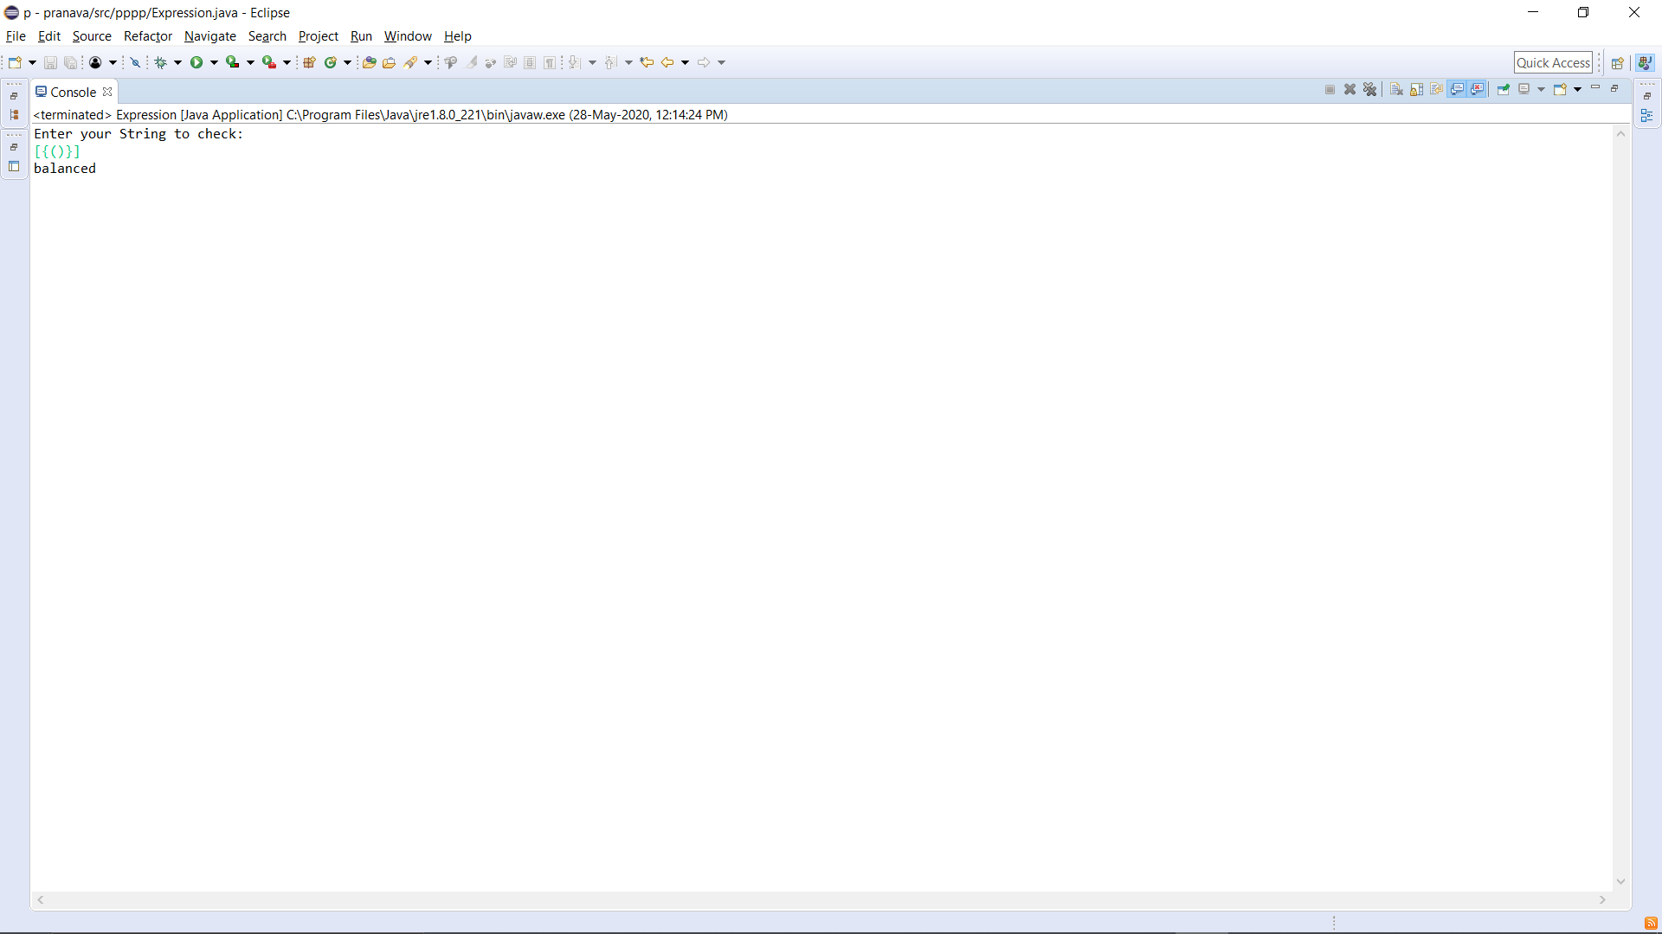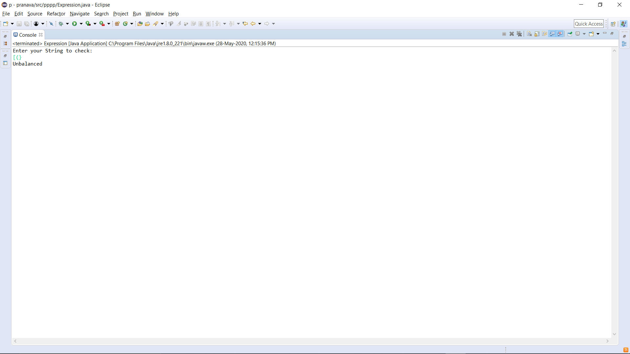

P-3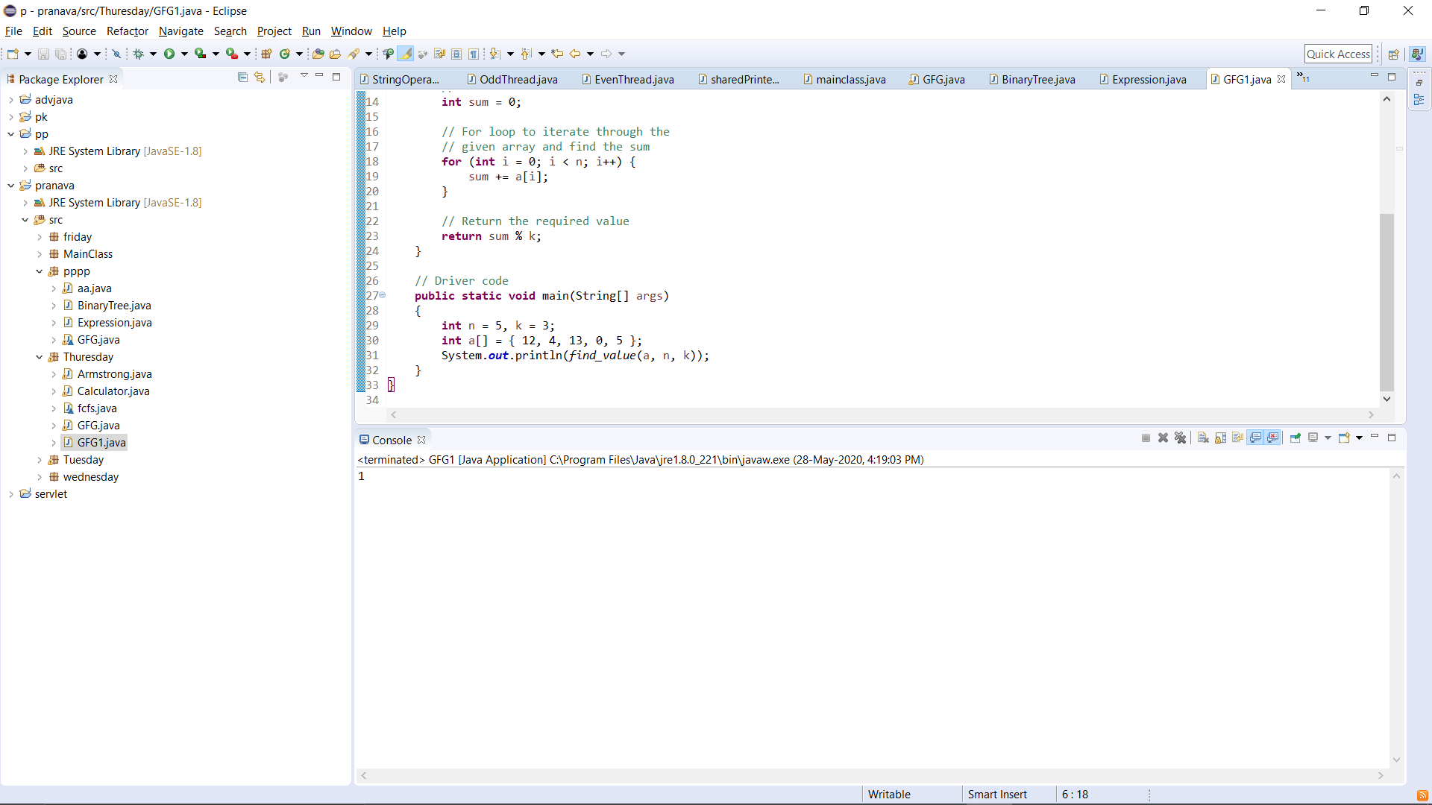

p-4

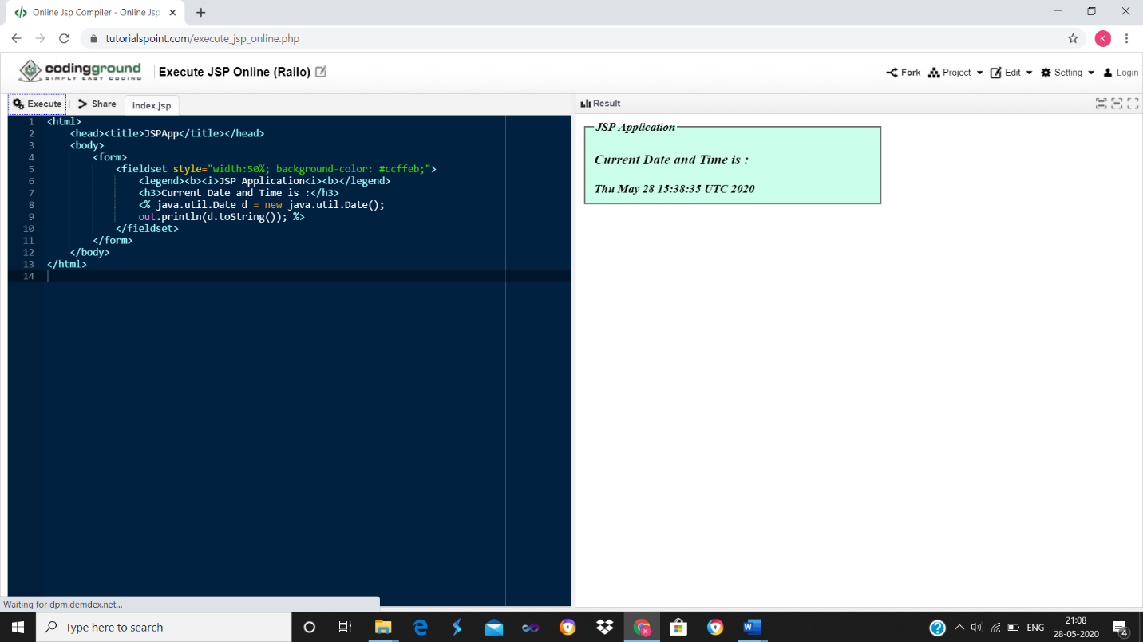

p-5

